**PART B – Micro–Project Report**

**Title of Micro-Project**

1. **Rationale:**

An IP address represents a unique address that distinguishes any device on the internet or any network from another. IP or Internet Protocol defines the set of commands directing the setup of data transferred through the Internet or any other local network. An IP address is represented by a series of numbers segregated by period (.). They are expressed in the form of four pairs - an example address might be 255.255.255.255 wherein each set can range from 0 to 255. IP addresses are not produced randomly. They are generated mathematically and are further assigned by the IANA (Internet Assigned Numbers Authority), a department of the ICANN.

A subnet, or sub-network, is a segmented piece of a larger network. More specifically, subnets are a logical partition of an IP network into multiple, smaller network segments. A subnet itself also may be segmented into smaller subnets, giving organizations the flexibility to create smaller subnets for things like point-to-point links or for sub-networks that support a few devices

A subnet is a logical division of a larger network. A portion of a network that shares a network address with other portions of the network and is distinguishable by a subnet. In a sub-netted network, the host portion of the address is further split into a subnet number and a host number by use of a subnet mask. This allows you to divide a network into smaller networks to enhance routing and logically group the computers and resources in your network.

1. **Course Outcomes Addressed:**
2. Analyse the functioning of data communication and computer network.

**3.0 Literature:**

Two versions of the Internet Protocol are in common use on the Internet today. The original version of the Internet Protocol that was first deployed in 1983 in the ARPANET, the predecessor of the Internet, is Internet Protocol version 4 (IPv4).By the early 1990s, the rapid exhaustion of IPv4 address space available for assignment to Internet service providers and end-user organizations prompted the Internet Engineering Task Force (IETF) to explore new technologies to expand addressing capability on the Internet. The result was a redesign of the Internet Protocol which became eventually known as Internet Protocol Version 6 (IPv6) in 1995.[3][4][5] IPv6 technology was in various testing stages until the mid-2000s when commercial production deployment commenced. Sub-netting. In order to address some of the problems of class full addressing, the technique of sub-netting was invented. Described in RFC 791 in 1984, sub-netting provided another level of addressing hierarchy by inserting a subnet part into the IP address between the network and local parts.

**4.0 Actual Methodology:**

A technology that can provide a mapping between private and universal addresses and at the same time support virtual private networks. Network Address Translation {NAT} The technology allows a site to use a set of private addresses for internal communication and a set of global Internet addresses (at least 1) for communication with the rest of the world.

A unique address is assigned to a computer called an Internet Attributed IP address. Internet user has to caption a set of IP address from Internet authority.

To subnet a network is to create logical divisions of the network. Subnetting, therefore, involves dividing the network into smaller portions called subnets. Subnetting applies to IP addresses because this is done by borrowing bits from the host portion of the IP address.

A basic understanding of how binary and decimal numbers work is required. In addition, these definitions and terms will get you started:

IP Address: A logical numeric address that is assigned to every single computer, printer, switch, router or any other device that is part of a TCP/IP-based network

Subnet: A separate and identifiable portion of an organization's network, typically arranged on one floor, building or geographical location

Subnet Mask: A 32-bit number used to differentiate the network component of an IP address by dividing the IP address into a network address and host address

Network Interface Card (NIC): A computer hardware component that allows a computer to connect to a network

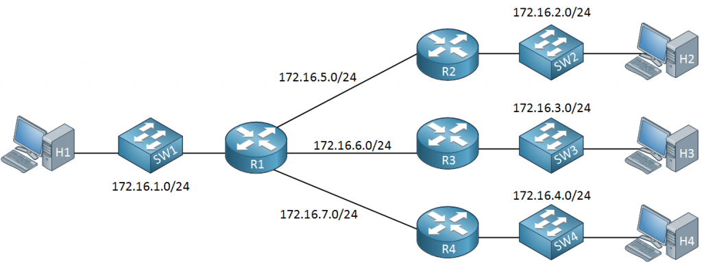

**5.0 Actual Resources Used (Mention the actual resources used).**

|  |  |  |  |  |
| --- | --- | --- | --- | --- |
| **Sr. No.** | **Name of Resource/Material** | **Specifications** | **Qty** | **Remarks** |
| **1.** |  |  |  |  |
| **2.** |  |  |  |  |
| **3.** |  |  |  |  |

**6.0 Output of Micro–Project:**

**7.0 Skills Developed/learned out of this Micro – Project:**

**8.0 Application of this Micro-Project:**

**9.0 Area of Future Improvement:**